# FactoryView 2014 Pro 自动化连接

## 概要：

WKE FactoryView连接自动化需要一个信号控制盒子，主要适用于信号的接收和信号输出使用，在ADU200控制盒子上面有输入INPUT和RELAY OUTPUT两组信号接受端子，其中INPUT是用于信号的输入，在FactoryView软件里面是接收的一个开关量，开关闭合时间不小于20ms，RELAY OUTPUT是用于测试进行和测试结束的信号输出。

## 接线方式：

可以参考附录 ADU200 USB Relay I/O Interface ( 5 Amp )* Connection Diagrams。

## 接口分配

|  |  |
| --- | --- |
| 功能 | ADU200端口 |
| 触发 | INPUT PA0 |
| 忙碌 | RELAY OUTPUT K2 |
| 通过 | RELAY OUTPUT K1 |
| 失败 | RELAY OUTPUT K0 |

## 时序图：

触发

忙碌

通过

失败

测试结果可以使用

## 附录

**ADU200 USB Relay I/O Interface ( 5 Amp )\***

**Connection Diagrams**

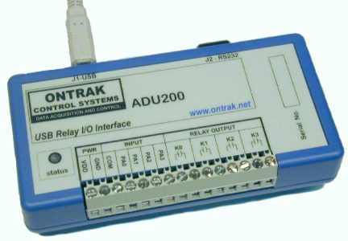说明: http://www.ontrak.net/ADUSDK/AduLogo.jpg

***Overview***

The ADU200 USB  Relay I/O Interface allows control of 4 relay contact outputs, 4 contact or TTL inputs, and 4 event counters via a USB port.  The ADU200 can effectively convert  a standard PC to a powerful   PLC ( programmable logic controller ). High quality PA-Series relays from Aromat offer superior performance.

***Input Connections:***

The [ADU200](http://www.ontrak.net/ADU200.htm) features 4, ISOLATED  digital inputs labeled, PA0 to PA3.

Dry contact inputs such as PLC contacts or pushbuttons can be connected to the digital inputs using the 5V power output of the ADU200. In this case, GND and COM and shorted and contacts are connected between VDD and the appropriate digital input.

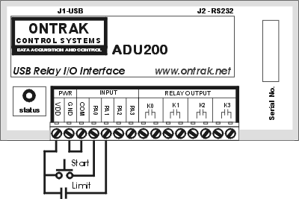

Figure 1: Contact Inputs

Figure 2 shows the connection of the same contact inputs using an external power supply. Note that in this case, no connection is made to the VDD or GND outputs of the ADU200.

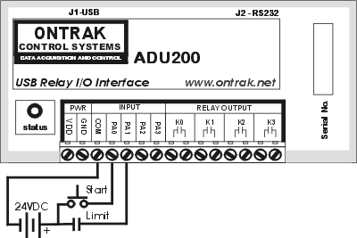

Figure 2: Contact Inputs ( 2 )

***Output Connections:***

The [ADU200](http://www.ontrak.net/ADU200.htm) features 4, 5 amp,  relay contact outputs labeled K0 to K3.

AC or DC loads can be controlled simply by using these contact outputs to switch the external supply to the external load. Figures 3 and 4 show basic output connections.

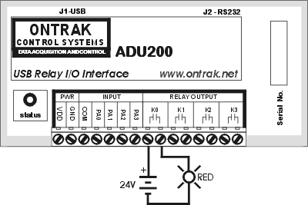

Figure 3: DC Loads

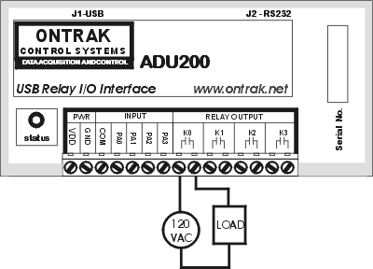

Figure 4: AC Loads

View the complete [ADU200](http://www.ontrak.net/ADU200.htm) data sheet [here](http://www.ontrak.net/ADU200.htm).